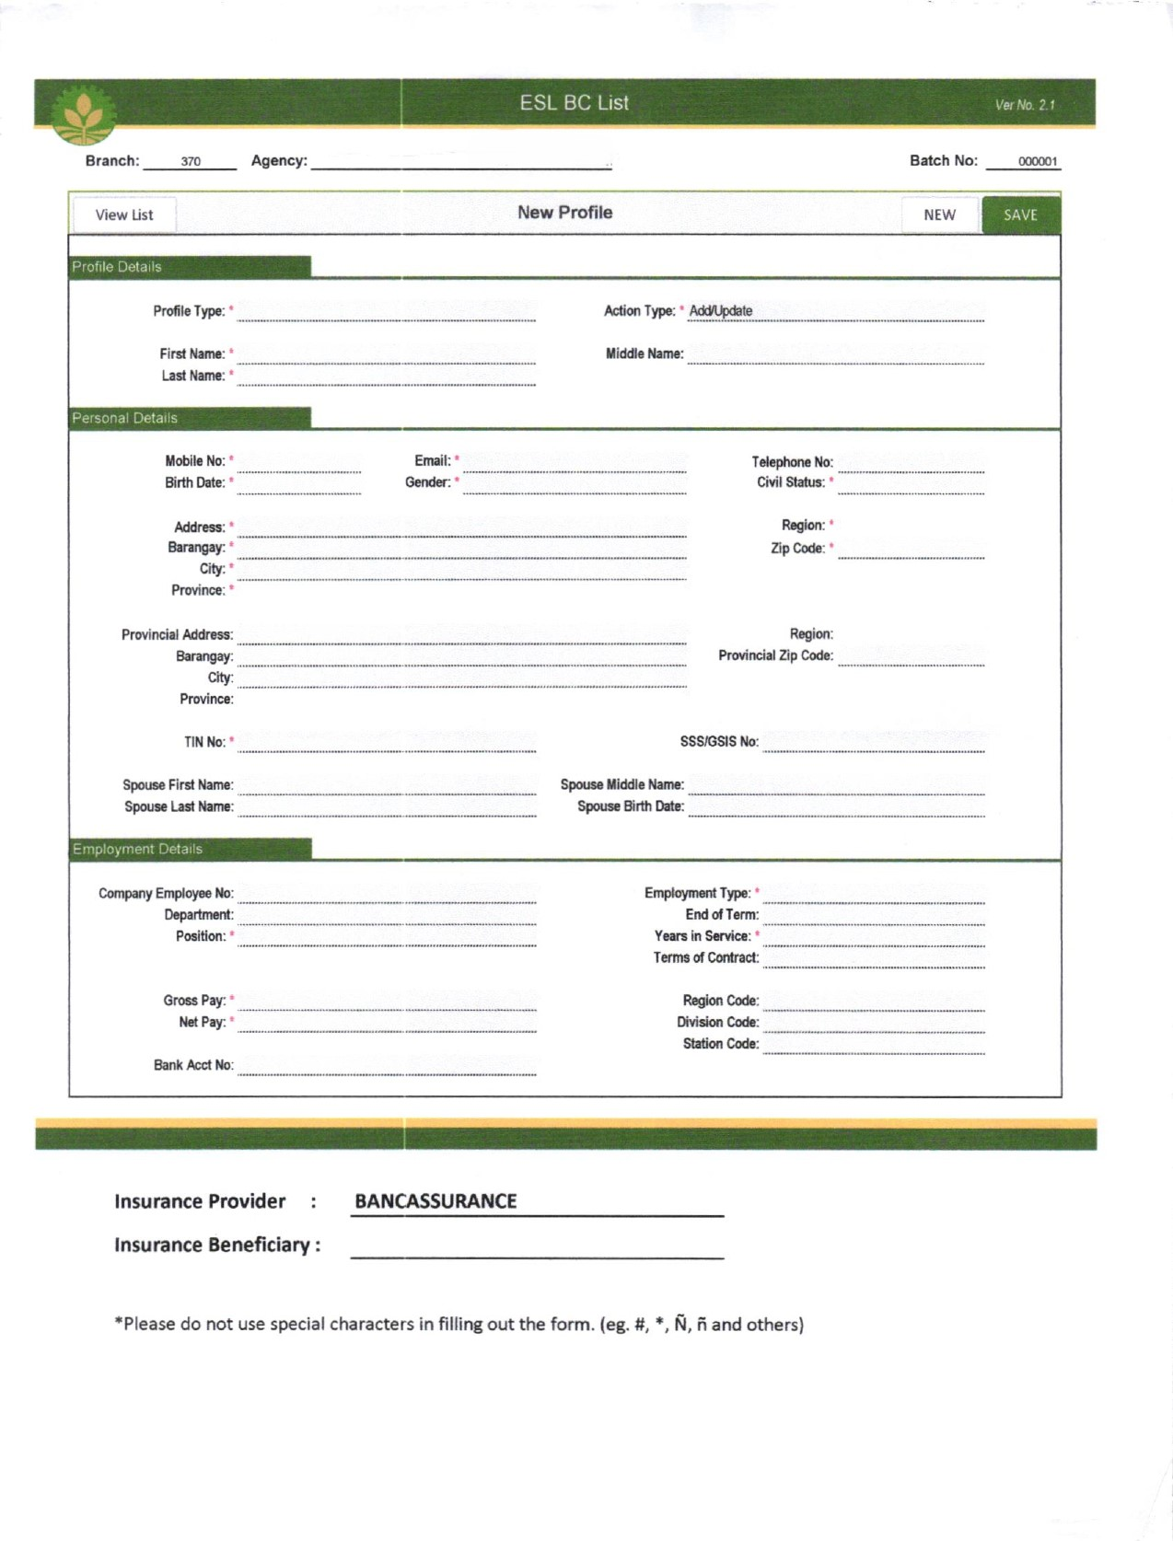
pppp
*
*
*
*
*
*
*
*
*
*
*
*
*
*
*
*
*
*
*
*
*
*
*
*
*
*
BORROWER
0039 – CAGAYAN VALLEY MEDICAL CENTER
*
*
*
*
*
*
*
*
*
*
*
*
*
*
*
*
*
*
*
*
*
*
*
*
*
*
*
CO-MAKER
0039 – CAGAYAN VALLEY MEDICAL CENTER

